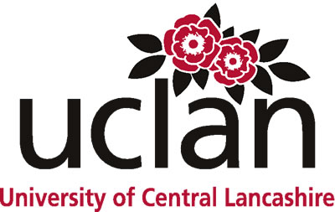
Conference Announcement and Call for Papers
Supporting Internationalisation through Languages and Culture in the 21st Century University
A conference sponsored by the School of Languages and International Studies at the University of Central Lancashire, Preston, UK, 19 – 20 July 2012
Background
Internationalisation is a key issue impacting on Higher Education today. As the Times Higher Education recently put it, ‘[t]here can be no doubt that higher education is internationalising at a rapid rate’ (Times Higher Education, 11 November 2010: 5). And, as the International Association of Universities’ latest Global Survey attests, out of a poll of 745 universities across 115 nations, ‘internationalisation’ features in the strategic plans of 87% of them, with 78% of institutions noting its growing importance in the past three years (ibid.). But what is actually meant by ‘internationalisation’, and what are the intersections between this idea and the notion of ‘global citizenship’ which also frequently features highly on today’s Higher Education agenda? How does the promotion of foreign language-learning and intercultural communication help inform the pursuit of internationalisation? And, as we move into the twenty-first century, how are universities meeting the challenges of developing languages-based curricula which reflect the requirements of an increasingly global market place?
Conference Aims
In providing an opportunity for colleagues to come together to discuss these questions, the conference aims to explore how language teaching and learning strategies and cross-cultural understanding support the cause of internationalisation in the modern Higher Education arena.
Call for Papers
Papers of 20-minutes’ duration are invited from scholars and practitioners in relation to the following areas:
- Developing international curricula to support universities’ internationalisation strategies;
- The role of second-language learning in the pursuit of internationalisation;
- English as a ‘world’ language;
- Promoting the vocational properties of language-learning for the world stage;
- Employability through language-based curricula; and
- Intercultural communication.

Abstract Guidelines
Abstracts of no more than 250 words should be submitted by e-mail to the Internationalisation 2012 Conference email, I2012@uclan.ac.uk.
Please include the name(s) of the author(s), correspondence address, telephone number and e-mail address, together with a brief biography of the proposer(s).
The deadline for the submission of abstracts is 31 January 2012. All proposals will be peer-reviewed and all decisions finalized by 28 February 2012.

Who should attend the conference?
The conference will be of interest to a wide audience of practitioners working in Higher Education Languages Departments whose work embraces institutional strategies of internationalisation.
Please note that presenters will be expected to pay the conference fee, which will be £200 for the 2 days, including 1 night accommodation and the conference dinner. Day delegate rates may also be available.

Enquiries
For further information about the conference, please contact Liz Roberts, +44 (0)1772 893809, email the Internationalisation 2012 Conference email I2012@uclan.ac.uk or check out the conference website www.uclan.ac.uk/conferences and click on the forthcoming conferences link which will be updated once more information is available.

